Homework #7
Nonlinear Programming

6-38. Let X₁ = number of four-cylinder engines to produce, and X₂ = number of six-cylinder engines to produce.

Objective: Maximize profit = X₁(1,800 - 50X₁) + X₂(2,400 - 70X₂) = 1,800X₁ –50X₁² + 2,400X₂ - 70X₂²

Subject to:
100X₁ + 130X₂ ≤ 5,000 hours
X₁, X₂ ≥ 0

Solution: See file P6-38.XLS.
 | X₁ | X₂
Solution value | 18.00 | 17.14
Profit |  |  | $36,771.43

6-40. There are three decision variables corresponding to the percent of the portfolio dedicated to Alpha, Beta, and Gamma.

Objective: Minimize variance = 3A² + 2B² + 2G² + 2AB - 1.1AG - 0.7BG

Subject to six constraints: total investment, minimum return, maximum Alpha, maximum Beta, maximum Gamma, and non-negativity.

Solution: See file P6-40.XLS.
 | A | B | G
Solution value | 0.21 | 0.33 | 0.46
Variance |  |  |  | 0.70

Homework #7 SOLUTIONS (Extra Problems)
Nonlinear Programming

1.

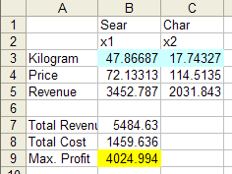

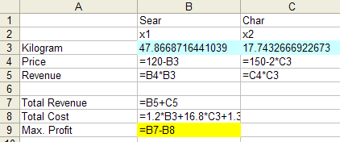

2. Total cost per pound is given by . Taking the first derivative and setting it to zero yields 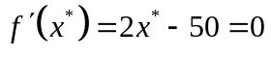, giving 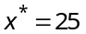 lbs. as the quantity that minimizes total cost per lb. This quantity produces a total cost of $3125.

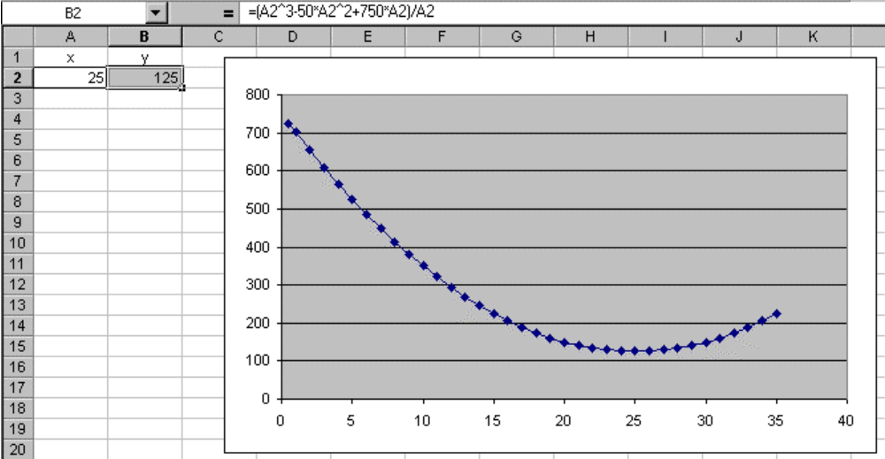
3.
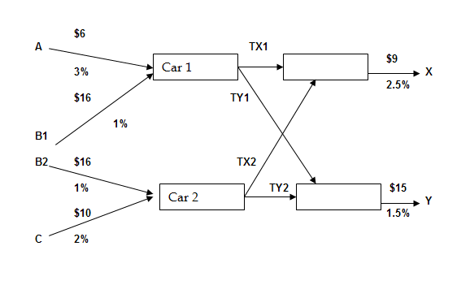
where

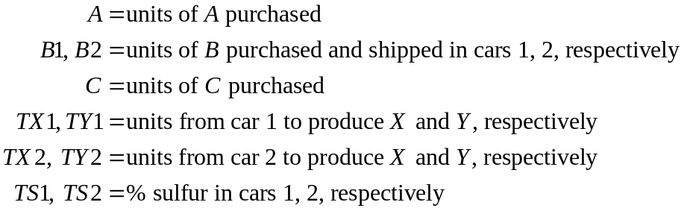

The NLP is

Max
s.t. | 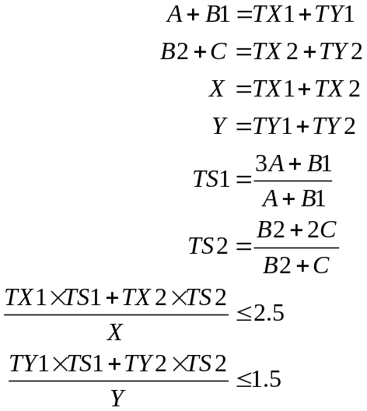  all var’s nonnegative

